CDR – clock and data recovery.

clock recovery is the process of extracting timing information from a serial data stream itself, allowing the timing of the data in the stream to be accurately determined without separate clock information.

How do CDR works?

Phase error detection –A phase detector or phase comparator is a [frequency mixer](https://en.wikipedia.org/wiki/Frequency_mixer), [analog multiplier](https://en.wikipedia.org/wiki/Analog_multiplier), or [logic](https://en.wikipedia.org/wiki/Digital_logic) circuit that generates a signal which represents the difference in phase between two signal inputs.

The phase detector is an essential element of the [phase-locked loop](https://en.wikipedia.org/wiki/Phase-locked_loop) (PLL). The detecting phase difference is important in other applications, such as [motor](https://en.wikipedia.org/wiki/Electric_motor) control, [radar](https://en.wikipedia.org/wiki/Radar), and [telecommunication](https://en.wikipedia.org/wiki/Telecommunication) systems, servo-mechanisms, and [demodulators](https://en.wikipedia.org/wiki/Demodulator).

Phase detectors for [phase-locked loop](https://en.wikipedia.org/wiki/Phase-locked_loop) circuits may be classified in two types.

A Type I detector is designed to be driven by analog signals or square-wave digital signals and produces an output pulse at different frequency. The Type I detector always produces an output waveform, which must be filtered to control the phase-locked loop [voltage-controlled oscillator](https://en.wikipedia.org/wiki/Voltage-controlled_oscillator) (VCO).

A type II detector is sensitive only to the relative timing of the edges of the input and reference pulses and produces a constant output proportional to phase difference when both signals are at the same frequency. This output will tend not to produce a [ripple](https://en.wikipedia.org/wiki/Ripple_(electrical)) in the control voltage of the VCO.

Type 1 use only xor

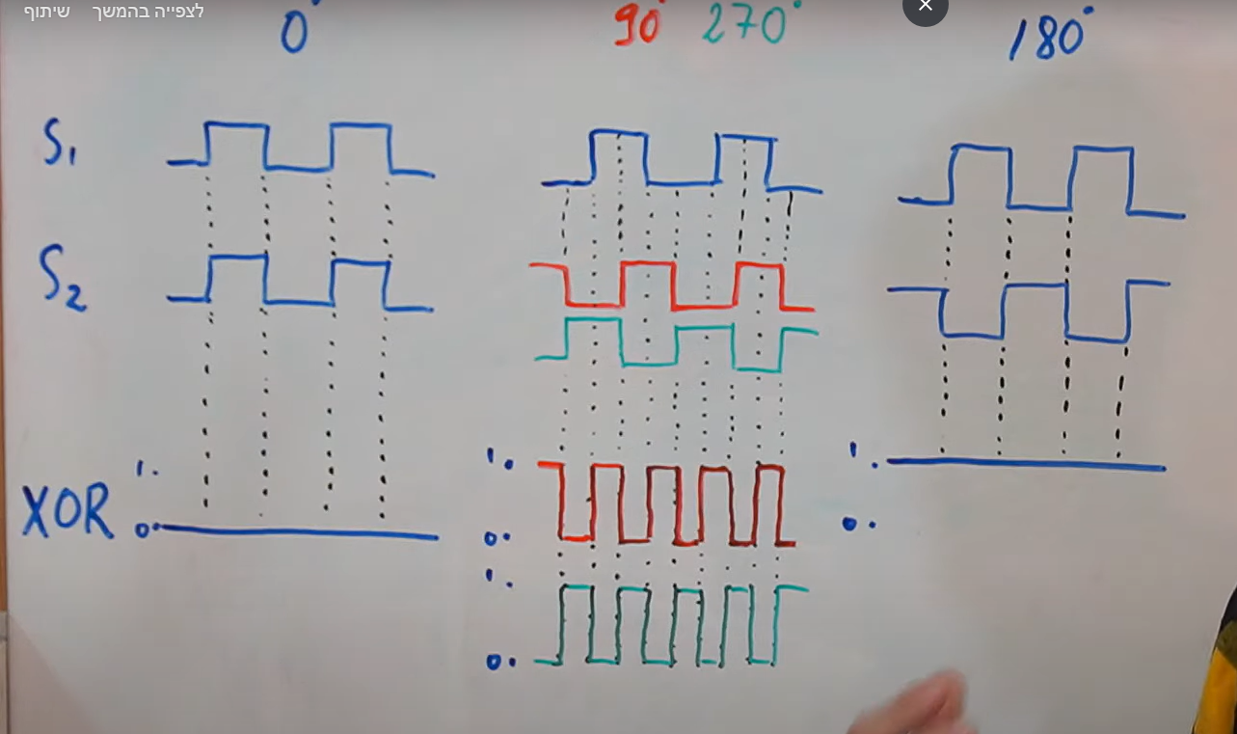

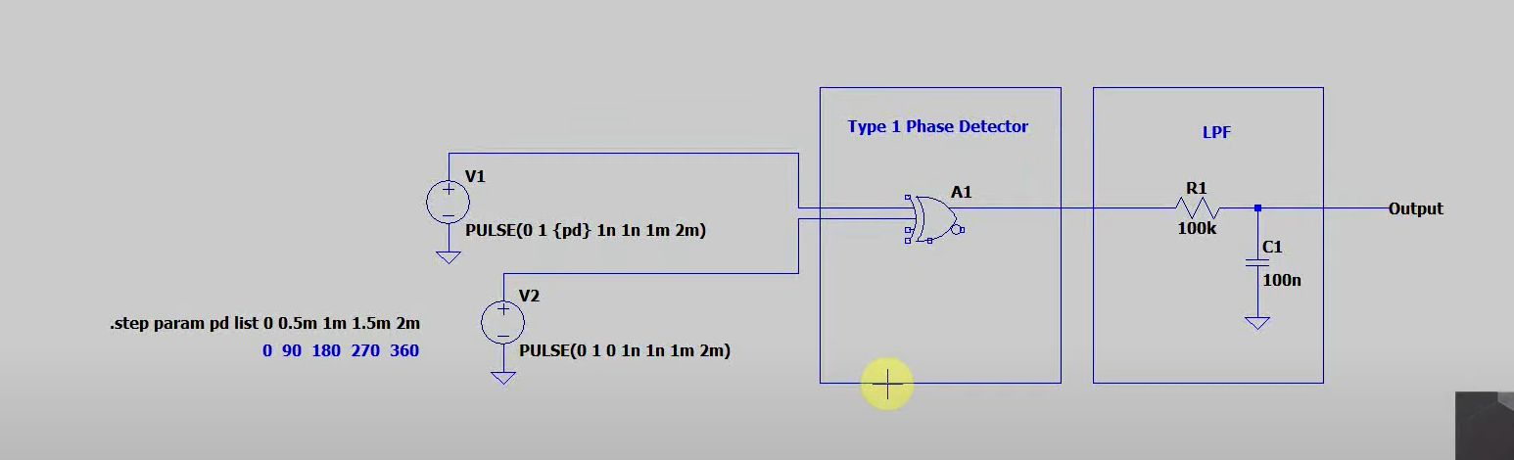

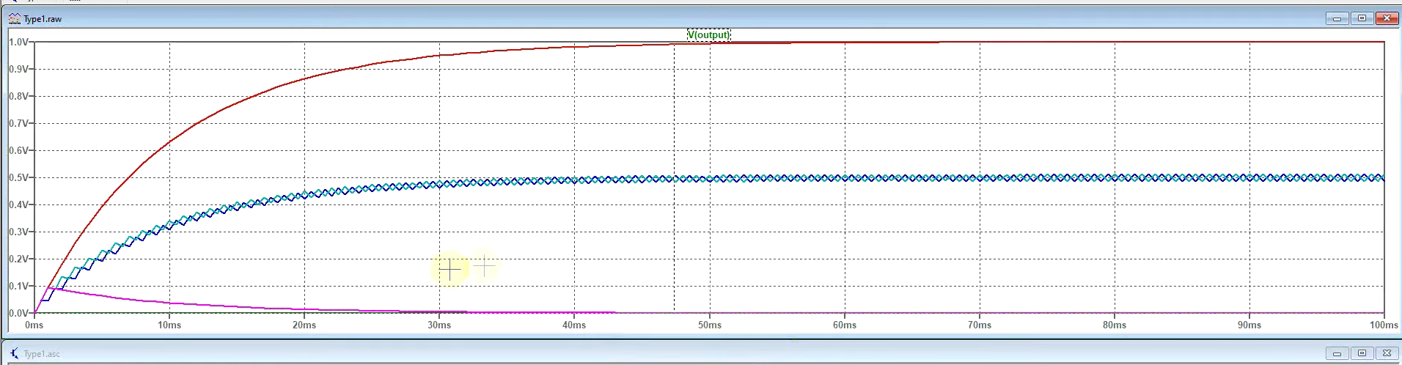

Type 2 –

יש הבדל בין בין מינוס 270 לפלוס 90

נותן לנו מידע מה מקדים את מה

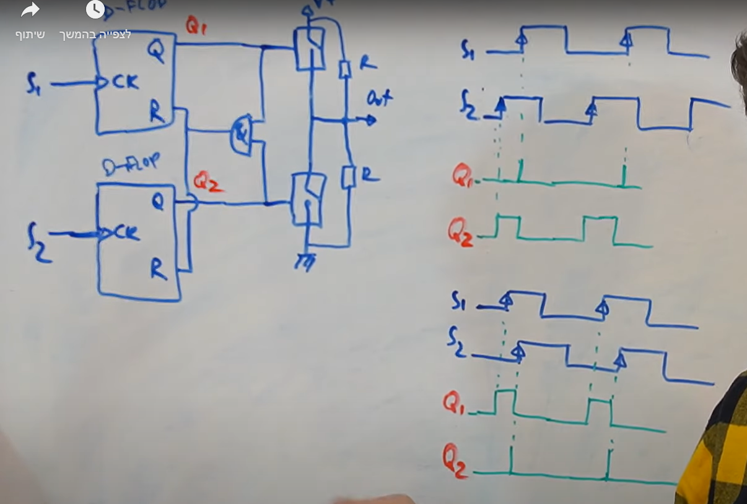

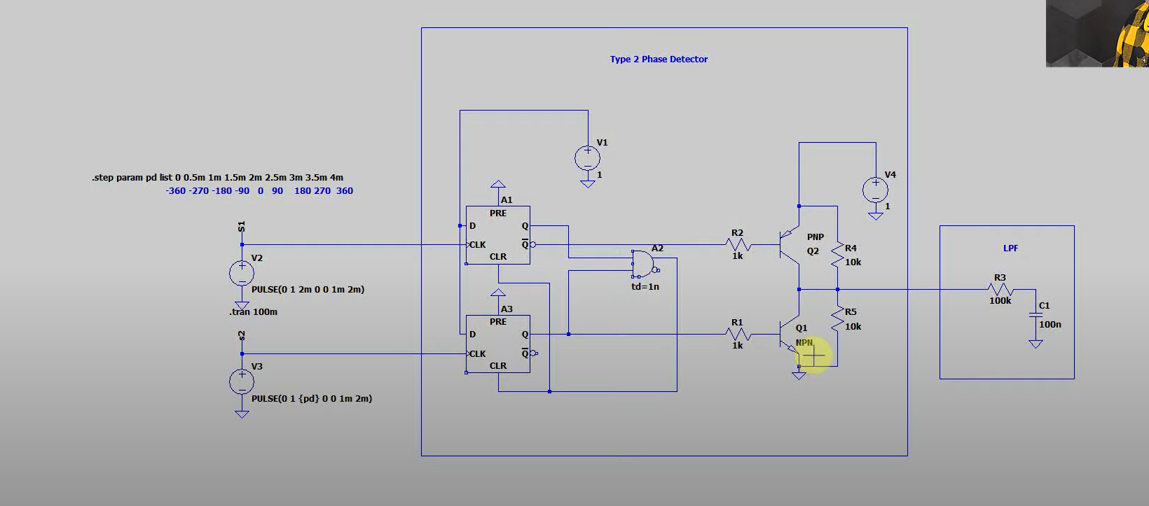

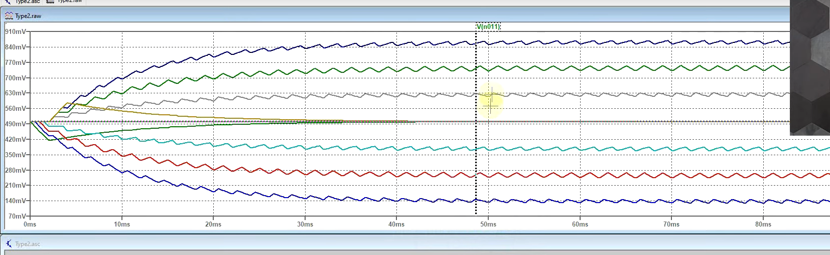

VCO – A voltage-controlled oscillator (VCO) is an [electronic oscillator](https://en.wikipedia.org/wiki/Electronic_oscillator) whose [oscillation](https://en.wikipedia.org/wiki/Oscillation) [frequency](https://en.wikipedia.org/wiki/Frequency) is controlled by a [voltage](https://en.wikipedia.org/wiki/Voltage) input. The applied input voltage determines the instantaneous oscillation frequency. Consequently, a VCO can be used for [frequency modulation](https://en.wikipedia.org/wiki/Frequency_modulation) (FM) or [phase modulation](https://en.wikipedia.org/wiki/Phase_modulation) (PM) by applying a [modulating](https://en.wikipedia.org/wiki/Modulation) signal to the control input. A VCO is also an integral part of a [phase-locked loop](https://en.wikipedia.org/wiki/Phase-locked_loop). VCOs are used in [synthesizers](https://en.wikipedia.org/wiki/Synthesizer) to generate a [waveform](https://en.wikipedia.org/wiki/Waveform) whose [pitch](https://en.wikipedia.org/wiki/Pitch_(music)) can be adjusted by a voltage determined by a [musical keyboard](https://en.wikipedia.org/wiki/Musical_keyboard) or other input.

Jitter transfer =| jitter(out)(f) / jitter(in)(f)|